COMMUNICATION AND VISUALIZATION FOR DATA ANALYTICS  
  
  
ALY6070, WINTER 2020  
MODULE 3 PROJECT ASSIGNMENT

Storytelling with Tableau

SUBMITTED BY: SIDDHARTH MANI, ANUPREETA MISHRA, SHIVANI ADSAR, PARINITA MAHINDRAKAR, SHRADDHA GOPALAKRISHNAN

NUID: 001410242, 001050752, 001399374, 001069354, 001069853, 001068448

SUBMITTED TO: PROF. JACK BERGERSEN

DATE: 03/27/2020

**Introduction**

In this assignment, we have worked on the “Bike Sharing Dataset” for performing data analysis to find how different variables affect the profit. We to also consider the changes in the environment and road conditions that affect the sharing [2]. This dataset gives information about the duration

of travel, departure and arrival position is explicitly recorded, corresponding to years 2011 and 2012 from Capital Bikeshare system, in Washington D.C. [1] We have performed explanatory analysis and Visualizations using Tableau software which helped in better analysis.

**Analysis**

In the “Bike Sharing Dataset”, we try to understand different variables affect the profit of Capital Bikeshare. There are three questions we ask about this data:

* To figure out which Type of users rent more, we use Fig 1.

1. Fig 1, depicts whether the bike rentals are by casual or registered users and shows the count of the rides for the year 2011 and 2012.
2. We see that the count for 2011-2012 Casual Rides are 247,252 and 372,765 respectively. About the Registered Rides, the figures are 995.8K (2011) and 167.6K(2012).
3. A close up of a map

   Description automatically generatedRegistered Users were responsible for around 4 times as many trips as Casual over the three months.

***Fig 1: Casual Vs Registered Bike Rides***

* To figure out which Year users rent more, we use Fig 2.

***Fig 2: Year On Year Analysis of Bike Rides***

1. Fig 2. portrays total count of the bike rides for the highlighted months January, June, September and October with peak count of 218.5K in September.
2. It can be observed that in 2012 the numbers have increased than that in 2011 maybe beacause people started becoming health conscious and more aware of the environment.

* A close up of a map

  Description automatically generatedTo figure out hourly trend, we use Fig 3.

1. We analyze that the count for both is highest for the hour 5 PM due to nice natural light and good evening weather.
2. 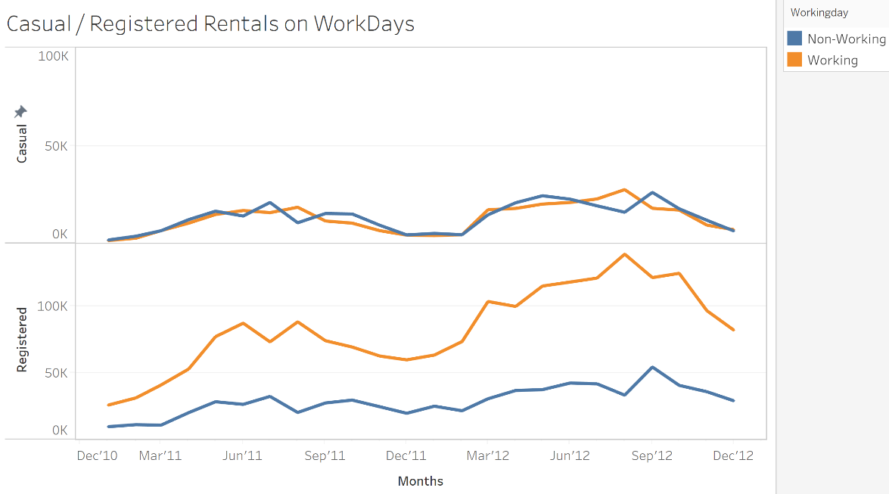There is a peak for average registered users around 8 AM which shows these rides could be regular bikers practicing for a nearing competition.

***Fig 3: Casual vs Registered Hourly Trend***

* To figure out week-day vs week-end trend, we use Fig 4 .

1. Registered users follow a seasonal pattern for working and non-working days.
2. As observed, the count of bike rides for casual users for working and non-working days was similar.

***Fig 4: Casual vs Registered on WorkDays***

1. The count of rides on working days for registered users is higher because of a fixed routine.

* To figure out hourly rental count for working days, we use Fig 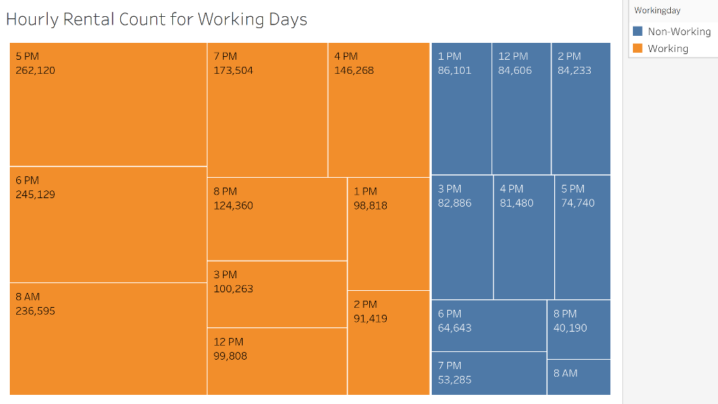5.

1. Maximum rentals observed in working days.
2. Peak hours of working days show highest count of rentals, as these are the hours during which people commuted to work from home and vice versa.

***Fig 5: Hourly Rental Count for Working Days***

1. A close up of a logo

   Description automatically generatedFor non-working days, highest count of rentals is 12-4 PM for leisure.

* To figure out hourly rental count over season, we use Fig 6.

1. This chart shows bike rentals for the four seasons where the darkest color indicates the highest value.
2. 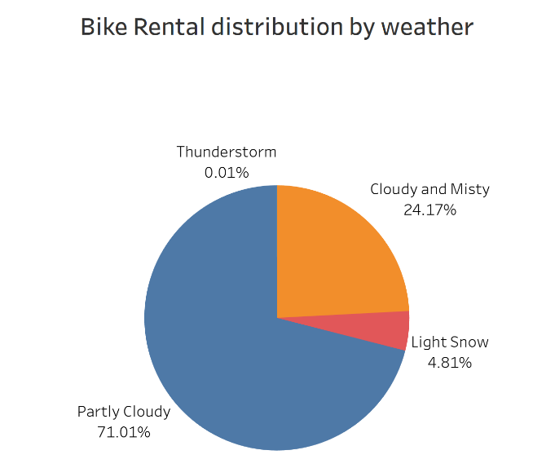As seen from the chart, Fall is the most appropriate weather for bike rentals followed by Summer, Winter and Spring.

***Fig 6: Seasonal Bike Ride Count***

1. Fall has the maximum count with 1.06M rides and Spring with 471.3K rides has the least count.

***Fig 7: Bike Rental distribution by weather***

* To figure out weather distribution, we use Fig 7.

1. When distributing rides based on weather, we get a beautiful Pie-chart depicting percentages of ride counts during different weather.
2. It can be noted that 71.01% of bike rentals happen on a Partly Cloudy weather followed by Cloudy and Misty weather at 24.17%.
3. 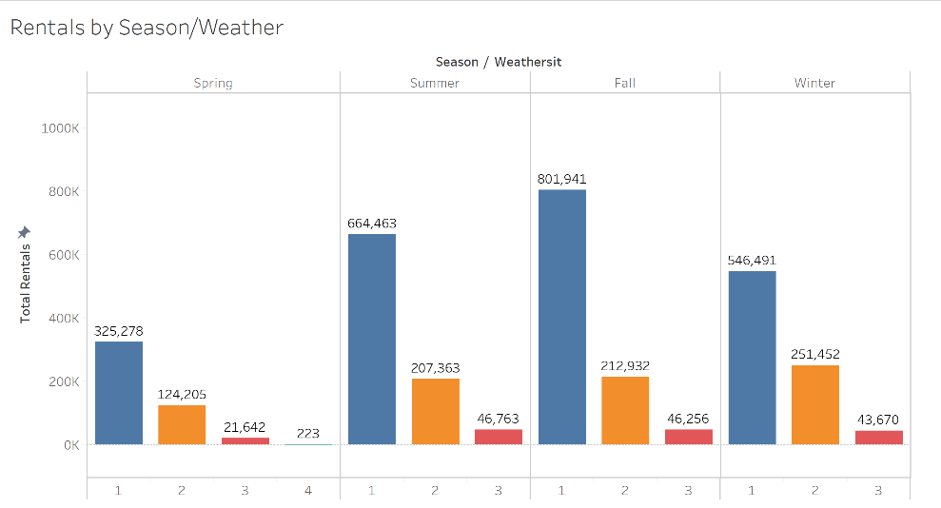The obvious reason for highest bike rentals on a Partly Cloudy weather is clear vision and track conditions

* To figure out rentals by weather, we use Fig 8.

1. Highest Rentals observed for Partly Clouded Weather followed by Mist + Cloudy and Light Snow.
2. 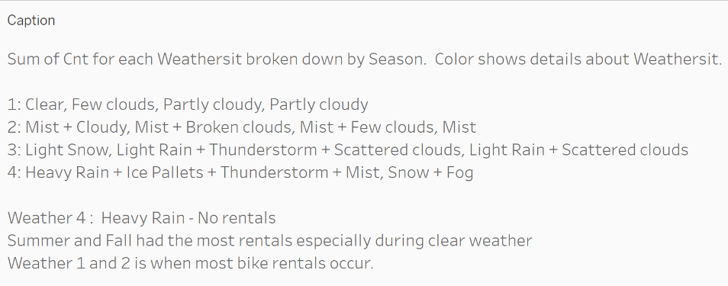Lowest Rental observed in Spring for Thunderstorm.
3. Clear weather during Fall season had the maximum number of Bike Rentals.

***Fig 8: Bike Rental by weather***

* 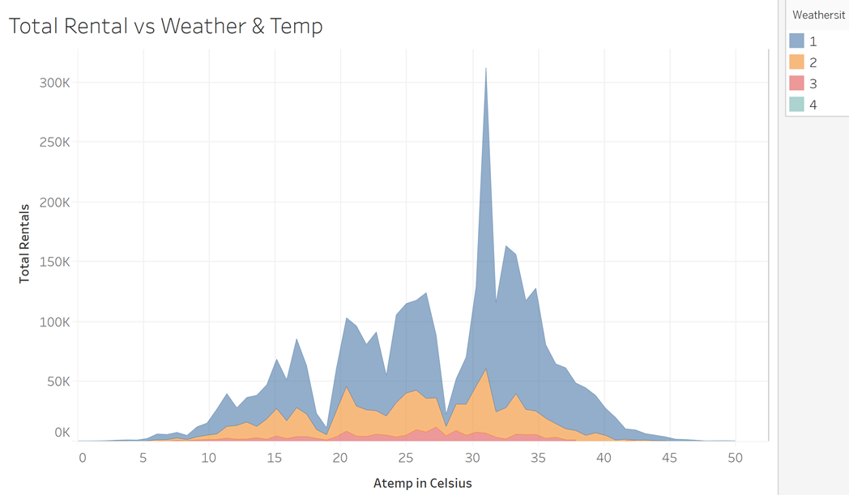To figure out total rentals vs weather and temperature, we use Fig 9.

1. Clear weather of 30-32 degree Celsius was preferred for renting bikes.
2. 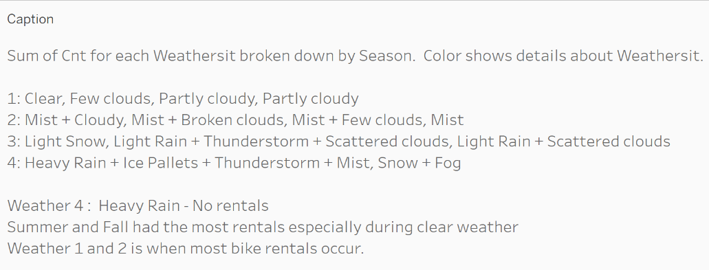We can see that the bike rentals were on the lower end for extreme temperatures while 20-35 degree Celsius was preferred across different weather conditions.

***Fig 9: Total Rental vs Weather and Temperature***

* 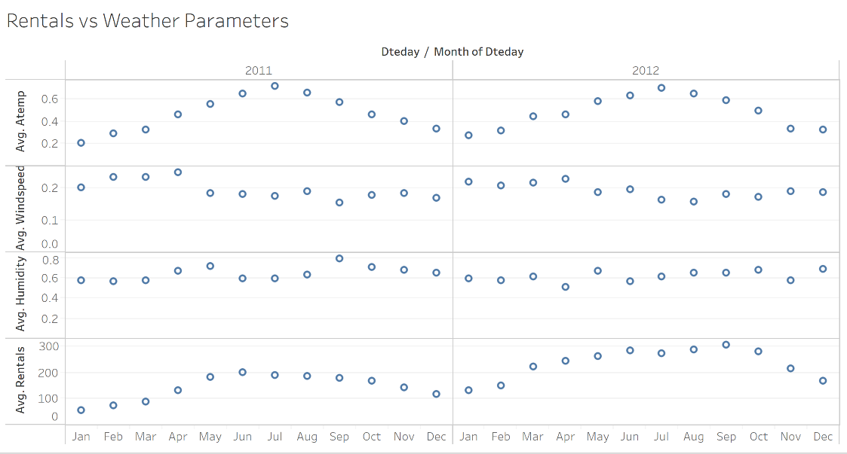To figure out rentals vs weather , we use Fig 10.

1. We here see the average rentals was dependent on the average temperature (Feeling temperature) and windspeed.

***Fig 10: Rentals vs Weather Parameters***

1. Higher temperatures and lower windspeed favored more rentals.
2. There seems to be no association between Humidity and Rentals

**Conclusion**

**Q1. How will you convert casual rides to registered rides?**

1. Promotions and making contract with companies for commuting purpose of employees will increase the count of registered users for working days.
2. Providing offers for registered users during holidays.

**Q2. How does the season and time affect the demand for bikes?**

1. People seem to ride bikes more during Fall as the temperature ranges between 30 and 32 degree Celsius.
2. Moreover, Fall attracts more tourists hence increasing the bike rentals.
3. Clear and Partly Cloudy weather provides a pleasant and safe environment for riding bikes.

**Q3. Why is there an increase of bike rentals over the two years?**

1. People have become more environment, health and money conscious.
2. Since it is a safer option, people started preferring bike rentals.
3. Bike Rentals are a cheaper alternative for students as compared to other transportation services.

**References**

1. Motivate International, Inc. (n.d.). System Data. Retrieved from http://capitalbikeshare.com/system-data
2. Analytic Methods in Research. (n.d.). Retrieved from <https://www.scopus.com/record/display.uri?eid=2-s2.0-85032566625&origin=inward&txGid=4e9a8dbe3510419b44349908631202af>